Tuesday, January 17, 2023
SPEC Meeting
Gonzaga University 5:15pm

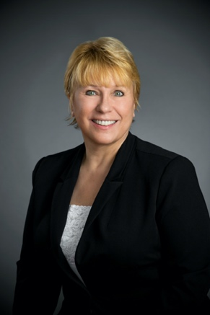
Christine Kuglin JD, LLM, CPA, CFE
Director - Truth in Accounting

Tools to Examine Government Spending: Where Do Your Tax Dollars Go?
This presentation will demonstrate the use of the free tools available from the Truth in Accounting (TIA) Project at the University of Denver. This includes Data-Z.org, a data aggregation website that has over 700 data sets available to customize charts and graphs. These can be used as simple data analysis tools for any profession. Audience members will choose data sets that serve their profession and will see the data come to life during the presentation.
TIA also produces annual State of the States, State of the Cities and State of the Federal Government reports based on data research and analysis of Annual Comprehensive Financial Reports. Participants will be shown the financial status of their government in comparison to other states.
Finally, participants will learn of the Financial Transparency Data Act which was passed by Congress in December 2022. This legislation is the beginning of a monumental shift in government reporting, like the XBRL /SEC movement in 2009. The demonstration will illustrate the ease of using public SEC reports and how this will be implemented in governmental reporting to create more transparency in how governments spend our tax dollars.

Speaker:
Christine Kuglin is the Director of Truth in Accounting Project at the University of Denver in Denver, Colorado. She has over ten years of tax and accounting firm experience, as well as ten years of college teaching experience. She served as a NASA grant accountant overseeing multi-million-dollar grant awards, taught at four diverse, post-secondary schools in Colorado, and was the Chair of the School of Professional Accounting at Eastern Washington University.

Some of her achievements include being awarded Instructor of the Year at Metropolitan State University of Denver in 2016, winning the 2019 National American Bar Association Tax championship while attending the University of Denver Sturm College of Law, and obtaining Distinguished Chair recognition by Eastern Washington University in 2022.

Christine earned bachelor and master’s degrees in accounting, a Juris Doctorate with an emphasis in Corporate and Commercial Law, and a post-JD Master of Laws in Taxation. She is an actively licensed Certified Public Accountant and attorney in Washington, and a licensed attorney Colorado. She also is a Certified Fraud Examiner.

Christine Kuglin JD, LLM, CPA, CFE
Director - Truth in Accounting
Daniels College of Business
School of Accountancy
University of Denver
Denver, CO 80208

Christine.kuglin@du.edu

